Day2 Assignment 1

Task 1.

SDLC Overview - Create a one-page infographic that outlines the SDLC phases (Requirements, Design, Implementation, Testing, Deployment), highlighting the importance of each phase and how they interconnect.

SDLC -software DEVELOPMENT LIFE CYCLE

======================================

SDLC is a process followed for software building within a software organization. SDLC consists of a precise plan that describes how to develop, maintain, replace, and enhance specific software. The life cycle defines a method for improving the quality of software and the all-around development process.

----------------------------------------------

Stages of the Software Development Life Cycle

----------------------------------------------

stage 1 . Planning and Requirement Analysis

stage 2 . Feasibility Study

stage 3 . Design

stage 4 . Coding

stage 5 . Testing

stage 6 . Maintenance

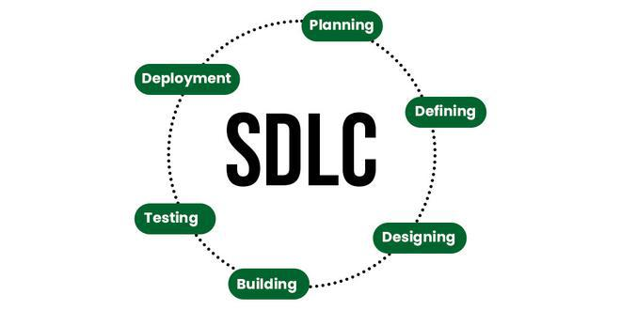

stage 1 . Planning and Requirement Analysis

------------------------------------------------------------------

--> Define Project Scop

--> Set Objective Goals

--> Resource Planing

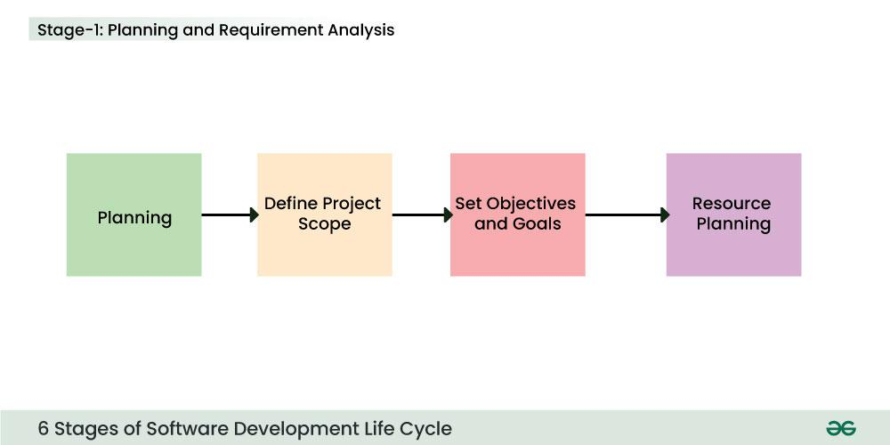

stage 2 . Feasibility Study

---------------------------------------------

--> A feasibility study is like checking the ground beneath it, the materials available to build it, and the overall design to see if the bridge can actually be constructed. It's an analysis that assesses the viability of a proposed software solution from three key angles.

stage 3 . Design

----------------------------------------------

--> It reference for software designers to come up with the best architecture for the software. Hence, with the requirements defined in SRS, multiple designs for the product architecture are present in the Design Document Specification .

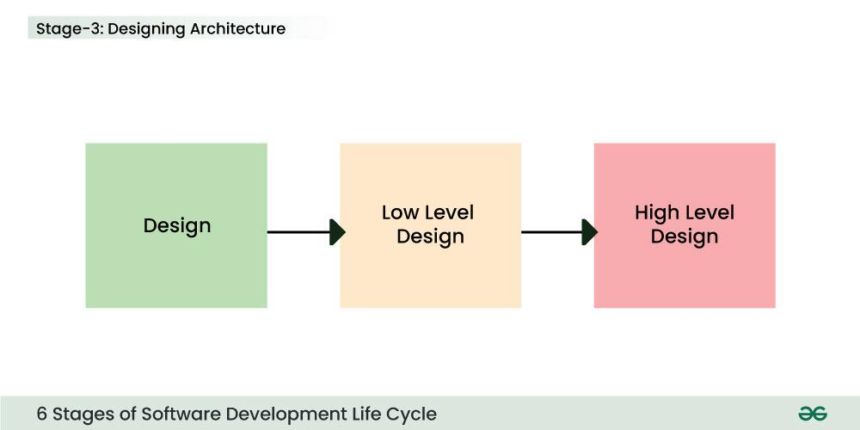

// High level design // Low level Design

stage 4 . Coding/ Development

-----------------------------------------------

--> At this stage, the fundamental development of the product starts. For this, developers use a specific programming code as per the design in the DDS. Hence, it is important for the coders to follow the protocols set by the association. Conventional programming tools like compilers, interpreters, debuggers.

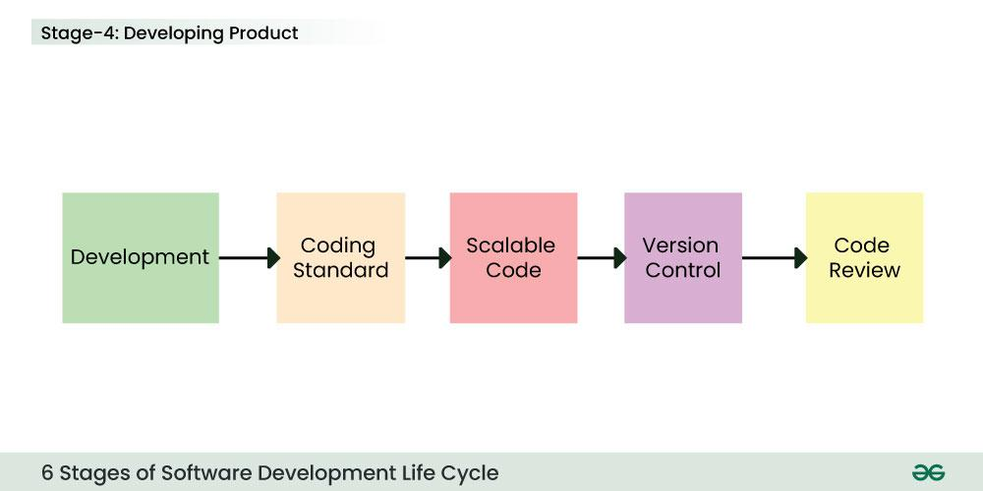

stage 5 . Testing

-----------------------------------------------

-->After the development of the product, testing of the software is necessary to ensure its smooth execution. Although, minimal testing is conducted at every stage of SDLC. Therefore, at this stage, all the probable flaws are tracked, fixed, and retested. This ensures that the product confronts the quality requirements of Software.

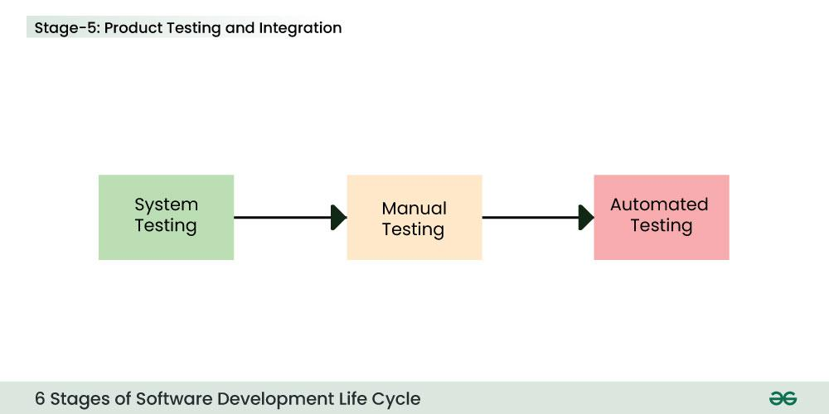

stage 6 . Maintenance

------------------------------------------------

--> It is important to ensure its smooth performance. If it performs well, the organization sends out the product as a whole. After retrieving beneficial feedback, the company releases it as it is or with auxiliary improvements to make it further helpful for the customers. However, this alone is not enough. Therefore, along with the deployment, the product’s supervision.

